 SEMINAR REPORT 

A seminar Report on
Student Skills and Course Recommendation System

Submitted in partial fulfilment for the award of
THIRD YEAR DIPLOMA IN
COMPUTER ENGINEERING
By
Sr. No | Enrollment Number | Name of student
1 | 23610960223 | Gayatri Rajendra Khairnar
2 | 23610960293 | Sanskriti Nitin Thakare
3 | 24610960184 | Tejashri Jitendra Borse
4 | 24610960256 | Sonali Mahesh Patil

FOR THE ACADEMIC YEAR : 2026 – 2027
DEPARTMENT OF COMPUTER ENGINEERING
S.S.V.P.S's Bapusaheb Shivajirao Deore Polytechnic, Dhule
(Institute Code : 0059)

S.S.V.P.S's Bapusaheb Shivajirao Deore Polytechnic, Dhule
(An Affiliated Institute of Maharashtra State Board of Technical Education)
DEPARTMENT OF COMPUTER ENGINEERING

CERTIFICATE

Sr. No | Enrollment Number | Name of student
1 | 23610960223 | Gayatri Rajendra Khairnar
2 | 23610960293 | Sanskriti Nitin Thakare
3 | 24610960184 | Tejashri Jitendra Borse
4 | 24610960256 | Sonali Mahesh Patil

of CO5K Semester of Diploma in Computer Engineering of S.S.V.P.S’s B. S. Deore Polytechnic, Dhule (Inst.Code: 059) has completed the term work satisfactorily in Course

Seminar Presentation and Project Initiation (Course Code: 315003) for the academic year 2026 to 2027 as prescribed in the curriculum.

Place : Dhule
Date : 17/10/2026..................

Signature: Signature:
Name : Name :

Subject Teacher Head of the Department
Mrs. Shraddha Hajari

TABLE OF CONTENT
Sr. No. | Chapter | Page No.
 | Abstract | i
 | List of Figures | ii
 | List of Tables | iii
1 | Introduction | 1
2 | Literature Review | 2
3 | Overview and Working of Student Skills and Course Recommendation System | 7
4 | Advantages and Disadvantages | 12
5 | Conclusion | 13
6 | Project Initiation : | 14
6 | 6.1) Description of problem statement. | 14
6 | 6.2) Scope and objectives. | 14
6 | 6.3) Stake holder | 15
6 | 6.4) Platform/ Equipment/ Resources identification. | 15
7 | Seminar Presentation | 18
 | Bibliography | 27
 | References | 28

ABSTRACT
Choosing the right course is important for students because it helps them develop useful knowledge and skills for their education and future careers. However, students may find it difficult to identify their strengths, understand skill gaps and select suitable courses from the large number of options available online and in educational institutions.
This seminar presents the Student Skills and Course Recommendation System. The system collects student information such as interests, current skills, academic background and career goals. It compares this information with course details, required skills and course levels, then recommends courses that may help the student improve existing skills or learn new ones. The report reviews recommender-system concepts, skill-based matching, educational recommendation and career guidance. Such a system can make course discovery more organized, but recommendations depend on accurate student information, up-to-date course data and fair matching rules.

LIST OF FIGURES
Fig. No. | Title | Page No.
3.1 | Working of Course Recommendation System | 8
3.2 | Architecture of Course Recommendation System | 10

LIST OF TABLES

Table No. | Title | Page No.
2.1 | Literature Review | 5
6.1 | Resources | 16

CHAPTER 1

INTRODUCTION

Education and employment requirements continue to change, and students need to keep learning new skills. Many students are unsure which course matches their interests, current knowledge and career plans. Course platforms offer many options, but comparing them one by one can take time. A recommendation system can help students shortlist relevant learning opportunities.
A Student Skills and Course Recommendation System uses student profile information to suggest suitable courses. A student may enter interests, skills already learned, education level and a target career. The system compares these details with course descriptions, prerequisites, topics and skills taught. It can use rule-based matching, keyword similarity or a scoring method to rank courses.
The proposed system follows a simple process. First, the student creates a profile and completes a skills assessment. The system analyses the profile, identifies skills the student wants to improve, and compares it with a course database. Each course receives a relevance score based on matching skills, interests, level and goals. The system displays ranked recommendations with course descriptions and the skills that each course may develop.
Research in recommender systems shows that recommendations can be based on content similarity, user preferences, ratings or a combination of methods. In education, recommendations should also consider prerequisites, learning level and the student's learning goals. Challenges include incomplete profiles, outdated course information, privacy, bias and the need to explain why a course is recommended.
The main objective of the Student Skills and Course Recommendation System is to help students identify courses that match their skills, interests and career goals. Its usefulness can be evaluated through recommendation relevance, coverage of different skills, ease of use, accuracy of course information and student feedback.

CHAPTER 2

LITERATURE REVIEW

Recommender Systems: An Introduction
Survey on Collaborative Filtering, Content-based Filtering and Hybrid Recommendation System (2015)
Recommender systems help users discover items from a large collection by estimating which options are relevant to their needs. Common approaches include content-based filtering, collaborative filtering and hybrid methods. For a student-course system, course descriptions and required skills can be compared with a student's profile.

Content-Based Recommendation
Content-based methods recommend items with features similar to a user's stated interests or previous choices. In this project, features may include course topics, skill tags, difficulty level and career area. This approach can work even when a new student has not rated any courses, provided the profile and course metadata are available.

Collaborative Filtering

A Hybrid Course Recommendation System for Limited Information Scenarios(2022)
Collaborative filtering uses patterns in the choices or ratings of similar users. A course liked by students with similar learning interests may be suggested to another student. This method can discover useful patterns, but it may perform poorly when there are few users or little rating data.

Hybrid Recommendation Methods

Hybrid Filtering Recommendation System in an Educational Context(2022 )
Hybrid systems combine multiple recommendation methods to improve coverage and relevance. A student-course system can combine skill matching with student ratings or course popularity. The final score should still reflect the student's goals and should not rely on popularity alone.

Educational Recommender Systems
Educational recommender systems support learners by suggesting learning resources, activities or courses based on learner characteristics and learning context. They need to consider prior knowledge, learning goals, prerequisites and level so that suggestions are useful rather than simply similar in wording.

Skills Gap Analysis and Career Guidance

Recommender Systems: A Survey” —( 2011)
Skills gap analysis compares a student's current abilities with the skills needed for a target role or learning objective. A recommendation system can identify missing skills and prioritize courses that teach them. Career information and skill requirements should be reviewed regularly because industry expectations can change.

Explainable Recommendations
Toward the Next Generation of Recommender Systems” —( 2005)
An explanation helps a student understand why a course appears in the recommendation list. For example, the system may state that a course matches the student's interest in web development and teaches JavaScript, a skill marked as a learning goal. Explanations can improve transparency and help students judge recommendations.

Privacy and Fairness in Recommendation
Hybrid Recommender Systems: A Systematic Literature Review” — (2019)
Student profiles can contain personal and educational information. A responsible system should collect only necessary data, protect it and explain how it is used. Recommendation rules should be checked for unfairly excluding students or repeatedly suggesting only popular courses

User Feedback and Recommendation Improvement
Item-Based Collaborative Filtering Recommendation Algorithms” — (2001)
Student feedback, such as saving a course, rating it or marking it as not relevant, can help improve future recommendations. Feedback should be optional and should be combined with profile matching rather than treated as a perfect measure of course quality.

10. Course Metadata and Data Quality

Evaluating Recommender Systems” — (2004)

Recommendations depend on reliable course metadata. Each course should have a title, provider, description, skill tags, level, prerequisites, duration and link where available. Missing or outdated details can lead to poor matches, so the course database should be reviewed and updated.

11.Ranking and Scoring
Recommender Systems Handbook — (2011)
A simple scoring model can assign weights to skill match, interest match, career relevance and level suitability. Courses with higher scores appear first. The weights should be documented and tested with sample profiles; the score is a guide and should not be presented as a guarantee of success.

12 .Evaluation of Recommender Systems
Toward the Next Generation of Recommender Systems—(2005)
A recommendation system can be evaluated using relevance measures and user feedback. Precision at K can measure how many of the top suggestions are relevant, while coverage checks whether the system recommends a broad range of suitable courses. Usability testing can show whether students understand and trust the results.

Table No 2.1: Literature review:
Sr. No. | Approach Type | Technologies Used | Dataset | Key Objective | Limitations
1 | Content-based recommendation | Course metadata, skill tags, keyword similarity | Student profiles and course catalogue | Match course topics and skills to student interests | Depends on accurate metadata and profile details
2 | Collaborative filtering | User-course interactions, ratings, similarity scoring | Course ratings or enrolment history | Suggest courses liked by similar learners | Cold-start problem when user or rating data is limited
3 | Hybrid recommendation | Content matching combined with user feedback | Profiles, course details and ratings | Combine profile relevance with learner preferences | More complex to build and explain
4 | Educational recommender systems | Learner profile, learning goals, prerequisites | Learning resources and course records | Recommend resources suitable for learner needs | Must consider learning context and prior knowledge
5 | Skills gap analysis | Skill taxonomy, target-role requirements, gap comparison | Student skills and career skill lists | Identify missing skills and related learning paths | Skill requirements can change and be incomplete
6 | Explainable recommendations | Rule-based reasons, feature matching | Student profile and course attributes | Explain why each course is recommended | Explanations must be clear and accurate
7 | Privacy and fairness | Access control, data minimization, bias checks | Student profile data | Protect learner data and reduce unfair outcomes | Requires ongoing review and secure implementation
8 | Feedback-based ranking | Ratings, saves, dismissals, relevance scores | Optional student feedback | Improve future recommendations | Feedback may be sparse or reflect personal bias
9 | Course metadata quality | Structured course fields and validation | Course catalogue | Provide comparable course information | Details may become outdated
10 | Weighted scoring | Skill match, interest match, level and goal weights | Profile and course feature vectors | Rank courses transparently | Weights need testing and can affect ranking
11 | Recommendation evaluation | Precision at K, coverage, user surveys | Test profiles and relevance judgements | Measure relevance and variety of suggestions | Needs representative test data
12 | User-centred design | Usability tests and student feedback | Student testing sessions | Make results understandable and easy to use | Small test groups may not represent all students

CHAPTER 3

OVERVIEW AND WORKING OF STUDENT SKILLS AND COURSE RECOMMENDATION SYSTEM

1. Overview of Student Skills and Course Recommendation System:
A Student Skills and Course Recommendation System is a software application that suggests learning courses based on a student's current skills, interests, education level and career goals. It organizes course information and presents relevant options to help students plan their learning.

2. Role of Student Profile and Skill Analysis:
The student profile stores information such as education level, skills, interests and target career. A skills assessment or self-rating helps identify strengths and learning needs. The system compares this profile with the skills taught by each course and its prerequisites.

3. Need for Intelligent Course Recommendation:
Searching for courses manually can be confusing because there may be many providers, levels and topics. A recommendation system can reduce this effort by filtering and ranking courses according to student needs. It supports decision-making but does not replace advice from teachers or career counsellors.

Working Principle:
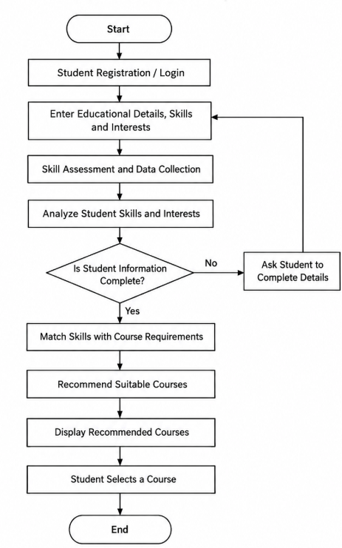
Figure 3.1: Working flow — Student Profile → Skill Assessment → Course Matching → Ranking → Recommendations → Student Feedback
The working of the Student Skills and Course Recommendation System consists of the following steps:
- Start: The student opens the application.
- Create Profile: The student enters education level, interests, current skills and career goals.
- Skill Assessment: The system records skills and identifies areas the student wants to improve.
- Validate Information: The system checks that required profile fields and course data are available.
- Identify Skill Gaps: The system compares current skills with skills needed for the student's learning or career goal.
- Match Courses: Course metadata is compared with the student's skills, interests, level and goals.
- Calculate Recommendation Score: Each course receives a score based on the matching criteria and their assigned weights.
- Rank Courses: Courses are sorted from most relevant to less relevant.
- Display Recommendations: The student sees course details, matching skills, prerequisites and learning outcomes.
- Collect Feedback: The student may save, rate or dismiss a recommendation to help improve future results.
- End: The student selects a course and plans the next learning step.

System Architecture and Main Components:

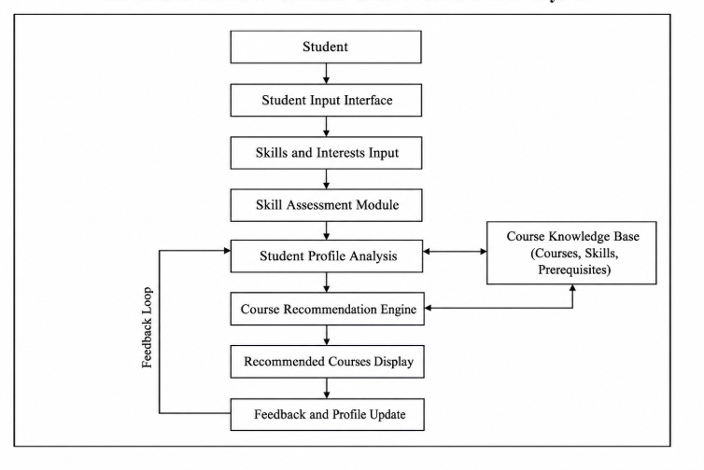
Figure 3.2: System architecture — Student Interface → Profile and Skill Module → Recommendation Engine ↔ Course Database → Ranked Results
The main components include the Student Interface, Profile Management Module, Skill Assessment Module, Course Database, Recommendation Engine and Results Interface. The profile module stores student preferences, while the skill assessment module records current and target skills.
The Recommendation Engine compares the student profile with course metadata and calculates relevance scores. The Results Interface displays ranked courses and explains the matching skills. An optional feedback module can record student responses and support later improvements.
The system should also include basic validation, secure data handling and an administration function for maintaining course information.

6. Technologies and Techniques Used:
A prototype can be developed using Python for recommendation logic and a web interface built with HTML, CSS and JavaScript. Flask or Django may be used for the backend, while SQLite or MySQL can store student profiles and course information. A rule-based scoring method is suitable for an initial version; later versions may use text similarity or machine-learning methods. The final stack depends on project requirements.

7. Example of Course Recommendation:
Consider a student who knows basic HTML and CSS, enjoys web development and wants to become a front-end developer.
The system identifies JavaScript, responsive design and front-end frameworks as relevant skills. It searches the course database and ranks beginner JavaScript and responsive web design courses higher than unrelated courses. Each result can show why it was recommended, what skills it covers and whether prerequisites are needed.

8. Results, Feedback and Human Review:
Students can review the suggested courses and decide which ones suit their time, budget and learning style. The system should show the basis of each recommendation and allow students to update their profile. Course information and recommendations should be checked periodically; the system provides guidance rather than guaranteeing employment or academic success.

CHAPTER 4

ADVANTAGES AND DISADVANTAGES

4.1 Advantages:
- Personalized Learning: Suggests courses according to each student's skills, interests and goals.
- Saves Time: Reduces the effort needed to search through many course options.
- Identifies Skill Gaps: Helps students recognize skills they may need to develop.
- Supports Career Planning: Connects learning choices with target careers or learning outcomes.
- Organized Course Discovery: Presents ranked suggestions with course details and reasons for matching.

4.2 Disadvantages:
- Incomplete Profiles: Missing or inaccurate student information can lead to unsuitable recommendations.
- Outdated Course Data: Course details, availability and prerequisites may change over time.
- Privacy Concerns: Student information must be stored and handled securely.
- Recommendation Bias: The system may over-recommend popular courses or overlook less common learning paths.
- Limited Judgment: A recommendation score cannot fully understand every student's circumstances and should be supported by human guidan

CHAPTER 5

CONCLUSION
The Student Skills and Course Recommendation System aims to help students choose relevant courses by matching their skills, interests, education level and career goals with course information. A profile and skill assessment provide the inputs, while a recomm
endation engine compares these inputs with course metadata and ranks suitable options.
The literature reviewed describes content-based, collaborative and hybrid recommendation methods, educational recommender systems, skills gap analysis, explainability and evaluation. A practical first version can use a transparent rule-based scoring method and a maintained course database. Its quality depends on reliable data, useful matching rules, privacy protection and student feedback.
In conclusion, the system can make course discovery more organized and support students in planning their learning. It should be treated as a decision-support tool, not as a replacement for teachers or career counsellors. Future improvements may include richer course data, feedback-based ranking, skill assessments and explainable recommendations.

CHAPTER 6

PROJECT INITIATION

6.1 Description of Problem Statement:
Students often have difficulty deciding which courses to take because they may not know how their existing skills relate to their interests or future career goals. Many course platforms list a large number of courses, making it difficult to compare topics, levels and prerequisites manually.
General course lists may not consider a student's current knowledge or specific skill gaps. If course details are incomplete or recommendations are based only on popularity, students may choose courses that are too advanced, too basic or unrelated to their goals.
Therefore, there is a need for a system that records student skills and interests, identifies learning needs, compares them with reliable course information and recommends relevant options with clear reasons. The proposed Student Skills and Course Recommendation System aims to support informed course selection while allowing students to make the final decision.

6.2 Scope and Objectives:
The scope of the project is to develop a student-facing application that collects student profile information, records current and target skills, stores course details and recommends courses based on a matching score. It may display course descriptions, skill outcomes, prerequisites and course links. The initial project focuses on course discovery and learning guidance; it does not guarantee academic results or employment.

Objectives of the Project:
- To study recommender-system approaches used for course and learning-resource recommendations.
- To collect student interests, education level, current skills and career goals.
- To maintain a structured database of courses and the skills they teach.

- To compare student profiles with course metadata using clear matching rules.
- To rank suitable courses and explain why they match the student's goals.
- To evaluate recommendation relevance, usability, data quality and student feedback.

6.3 Stakeholders:
The stakeholders are the people and organizations who use, develop, maintain or benefit from the Student Skills and Course Recommendation System.
- Students: Use the system to discover courses that match their skills and learning goals.
- Teachers and Academic Advisors: Help students interpret recommendations and plan learning pathways.
- Developers and Administrators: Build, test, maintain the application and update course information.
- Educational Institutions: May use the system to support student guidance and learning planning.
- Course Providers: Supply accurate course descriptions, prerequisites and skill outcomes.
- Project Guide and Evaluators: Guide development and evaluate the project's design, implementation and results.

6.4 Platform / Equipment / Resources:

1. Platform:
The system can be developed on Windows or Linux using Python for recommendation logic and HTML, CSS and JavaScript for the web interface. Flask or Django can provide backend services, and SQLite or MySQL can store profiles and course records. Visual Studio Code can be used for coding and testing.

2. Equipment:
- Computer or Laptop: Used for development, running and testing the application.
- Processor: A standard modern processor suitable for web development.
- RAM: 4 GB minimum; 8 GB recommended for comfortable development.
- Internet Connection: Needed to install libraries and access online course information where applicable.
- Storage: Enough space for source code, libraries, database files and test data.

3. Resources

Resources Table
Resources | Name | Purpose
Operating System | Windows 11 / Linux | Run development tools and the application.
Programming Language | Python 3 | Implement recommendation logic and backend services.
Code Editor | Visual Studio Code | Write, debug and test the project.
Web Framework | Flask or Django | Connect the web interface with backend logic.
Front-End Technologies | HTML, CSS, JavaScript | Build the student profile and recommendation pages.
Database | SQLite or MySQL | Store student profiles and course records.
Recommendation Method | Rule-based weighted scoring | Compare skills, interests, level and goals.
Version Control | Git and GitHub | Track code changes and support collaboration.

CHAPTER 7
Seminar Presentation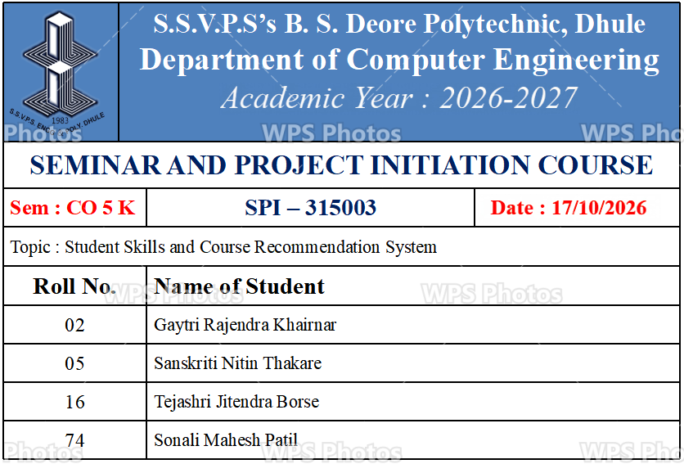 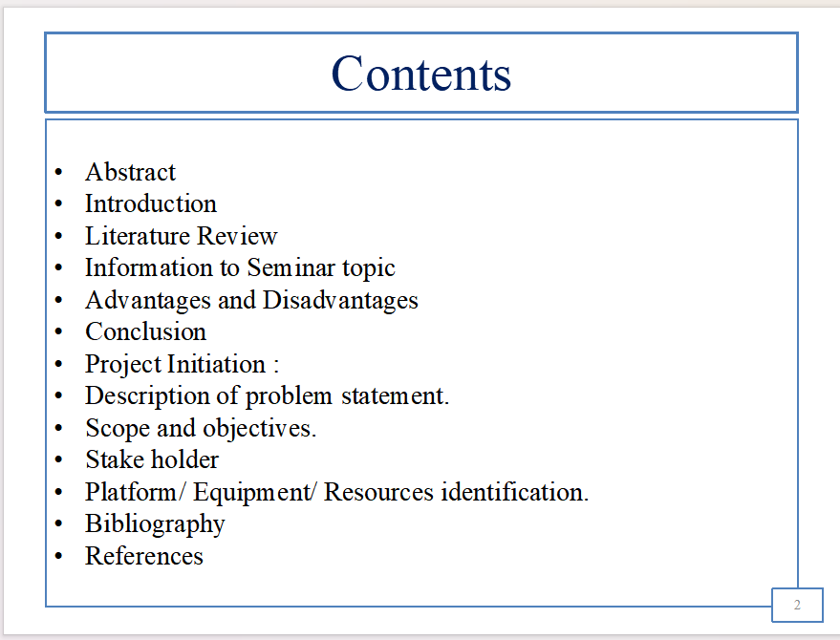
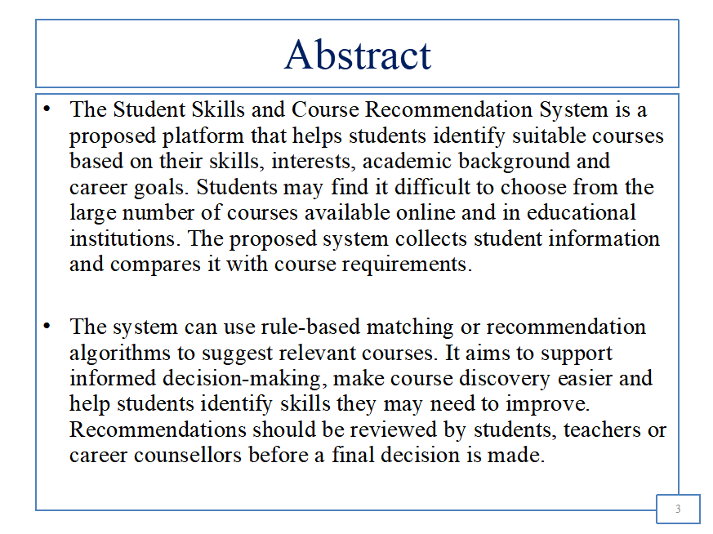

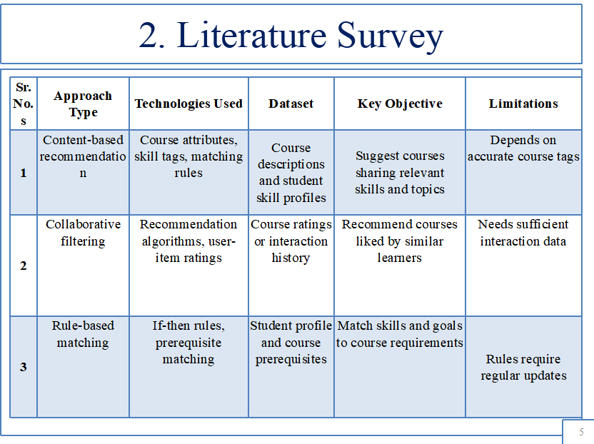
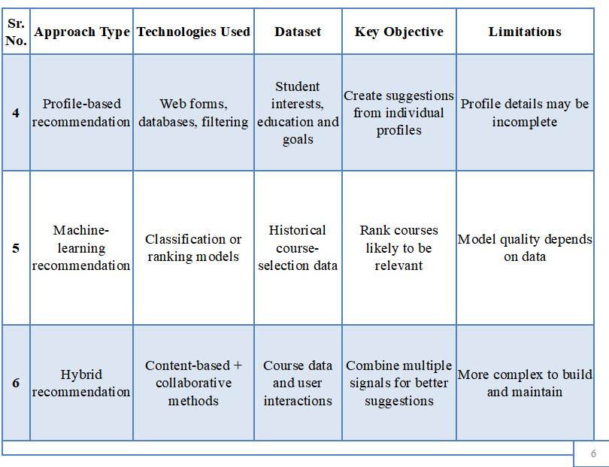

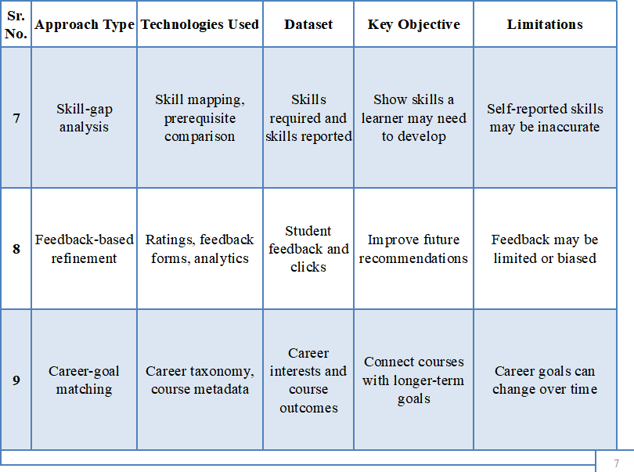
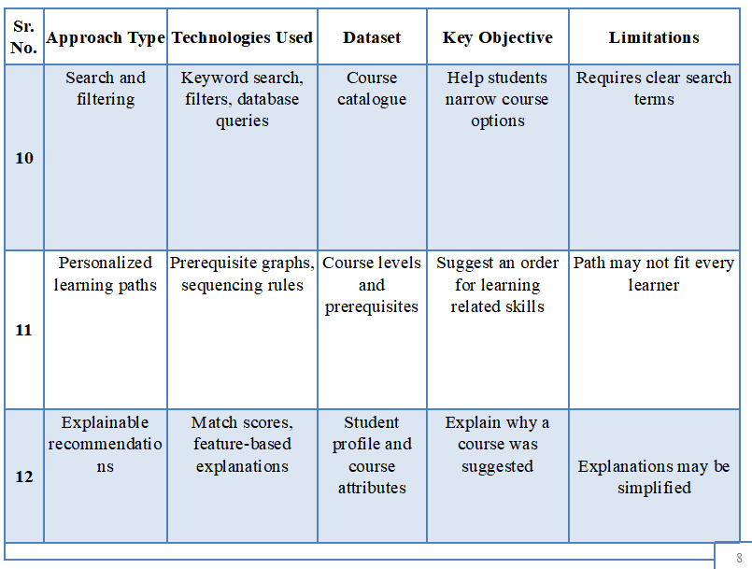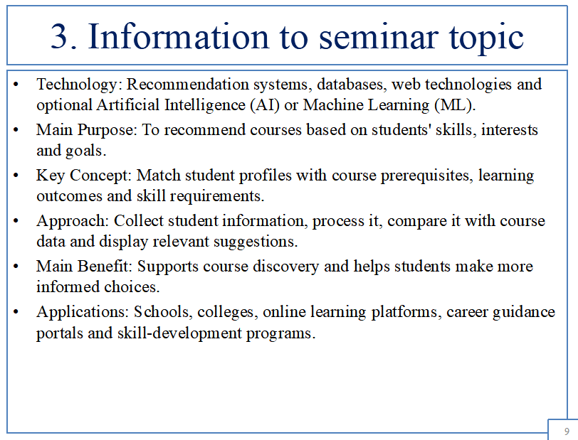
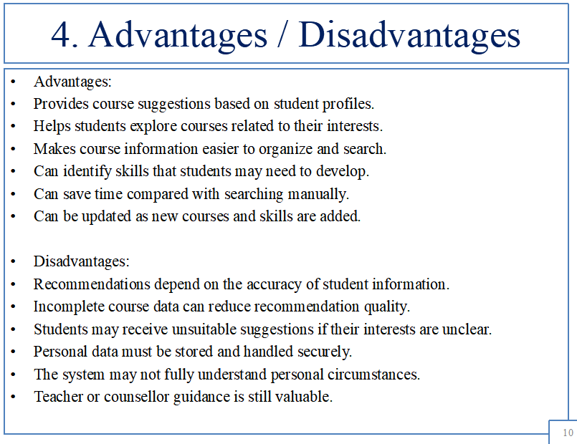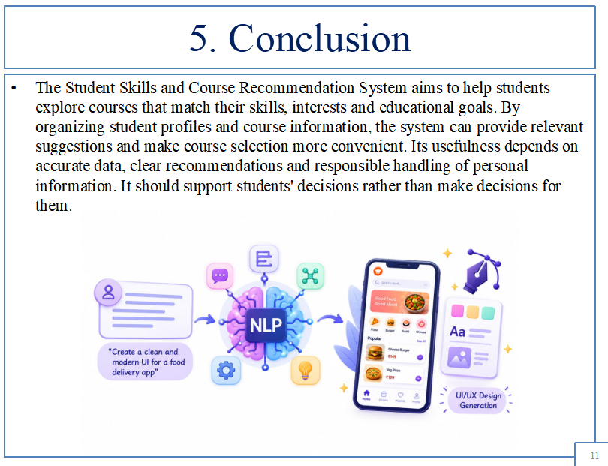
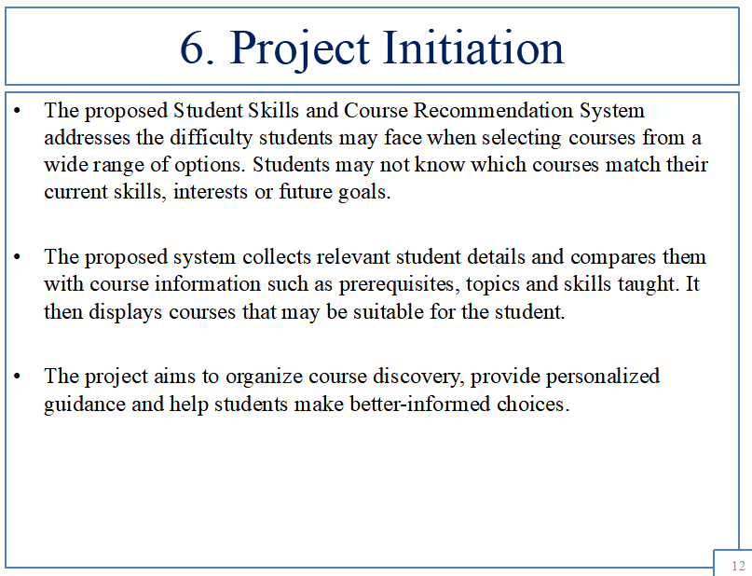

BIBLIOGRAPHY
Python Software Foundation. “Python Documentation.”
Available at: https://docs.python.org/3/https://spacy.io/
- Flask. “Flask Documentation.” Available at: https://flask.palletsprojects.com/https://docs.python.org/3/
- Django Software Foundation. “Django Documentation.” Available at: https://docs.djangoproject.com/https://huggingface.co/docs/transformers/
- SQLite. “SQLite Documentation.” Available at: https://www.sqlite.org/docs.htmlhttps://platform.openai.com/docs/
- MySQL. “MySQL Reference Manual.” Available at: https://dev.mysql.com/doc/https://developer.mozilla.org/
- scikit-learn. “Nearest Neighbors and Text Feature Extraction Documentation.” Available at: https://scikit-learn.org/stable/https://www.figma.com/developers
- UNESCO. “Guidance on AI and Education.” Available at: https://www.unesco.org/en/digital-education
https://www.nngroup.com/articles/ten-usability-heuristics/

REFERENCES
- F. Ricci, L. Rokach, and B. Shapira, eds., Recommender Systems Handbook, 3rd ed. Springer, 2022.https://arxiv.org/abs/2110.07775
- M. J. Pazzani and D. Billsus, “Content-Based Recommendation Systems,” in The Adaptive Web, Springer, 2007, pp. 325–341.
https://doi.org/10.1007/s10515-023-00377-x
- Y. Koren, R. Bell, and C. Volinsky, “Matrix Factorization Techniques for Recommender Systems,” Computer, vol. 42, no. 8, pp. 30–37, 2009.https://doi.org/10.70393/6a6374616d.333638
- P. Brusilovsky and E. Millán, “User Models for Adaptive Hypermedia and Adaptive Educational Systems,” in The Adaptive Web, Springer, 2007, pp. 3–53.https://arxiv.org/abs/2412.20071
  - https://doi.org/10.1016/j.aei.2025.103217
- G. Siemens and P. Long, “Penetrating the Fog: Analytics in Learning and Education,” EDUCAUSE Review, vol. 46, no. 5, 2011.https://doi.org/10.1145/3674399.3674455 https://doi.org/10.1145/3706598.3713285
- UNESCO, Guidance for Generative AI in Education and Research, 2023. Available at: https://unesdoc.unesco.org/
  - https://doi.org/10.1016/j.ijhcs.2025.103695
https://doi.org/10.1016/j.infsof.2026.108214

https://arxiv.org/abs/2506.10376 https://arxiv.org/abs/2511.08195
https://doi.org/10.55524/ijircst.2024.12.4.16

SEMINAR and PROJECT INITIATION Assessment / Evaluation
Sr. No | Enrollment Number | Name of student
1 | 23610960223 | Gayatri Rajendra Khairnar
2 | 23610960293 | Sanskriti Nitin Thakare
3 | 24610960184 | Tejashri Jitendra Borse
4 | 24610960256 | Sonali Mahesh Patil

Formative Assessment
Sr. No. | Criteria | Weightage | Exam Seat Number
Sr. No. | Criteria | Weightage | 388488 | 388492 | 388561 | 388518
1 | Selection Topic / Theme of seminar | 5
2 | Literature review and data presentation | 5
3 | Quality of Preparation and innovativeness | 5
4 | Q-A handling | 5
5 | Time Management | 5
6 | Seminar Presentation report | 10
7 | Selection of Theme of Problem Statementand its innovativeness | 5
8 | Stages of development of Action plan | 5
9 | Prototyping | 5
 | Total | 50
 | Scaled to 25

Sign :
Name : --------------------------------------
-(Course Expert/s)

